HALF/FULL ADDER & HALF/FULL SUBTRACTOR

Aim:
To realize half/full adder and half/full subtractor.
i.Using X-OR and basic gates.
ii.Using only NAND gates.

Apparatus Required:
Digital Trainer Kit, IC 7486, IC 7432, IC 7408, IC 7400, and connecting wires

Procedure:
1.Verify the gates.
2.Make the connections as per the circuit diagram.
3.Switch on V_{CC} and apply various combinations of input according to the truth table.
4.Note down the output readings for half/full adder and half/full subtractor sum/difference and the carry/borrow bit for different combinations of inputs.

Half Adder using basic gates:-
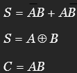
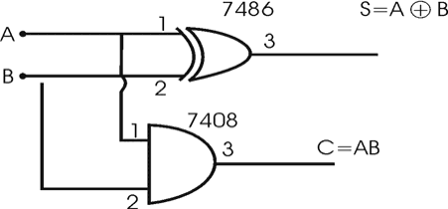
Full Adder using basic gates:-

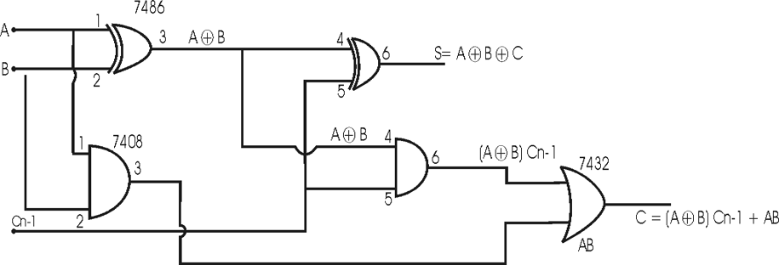

Half Adder using NAND gates only:-

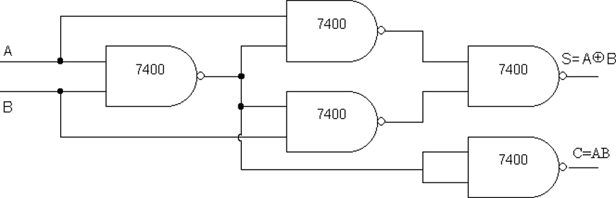

Full Adder using NAND gates only:-

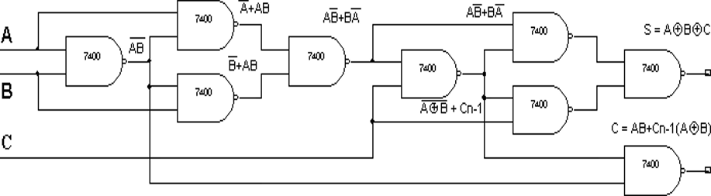

Half Adder
A | B | S | C | S(V) | C(V)
0 | 0 | 0 | 0 | 0 | 0
0 | 1 | 1 | 0 | 5 | 0
1 | 0 | 1 | 0 | 5 | 0
1 | 1 | 0 | 1 | 0 | 5

Full Adder
A | B | Cn-1 | S | C | S(V) | C(V)
0 | 0 | 0 | 0 | 0 | 0 | 0
0 | 0 | 1 | 1 | 0 | 5 | 0
0 | 1 | 0 | 1 | 0 | 5 | 0
0 | 1 | 1 | 0 | 1 | 0 | 5
1 | 0 | 0 | 1 | 0 | 5 | 0
1 | 0 | 1 | 0 | 1 | 0 | 5
1 | 1 | 0 | 0 | 1 | 0 | 5
1 | 1 | 1 | 1 | 1 | 5 | 5

RESULT:
Thus the half adder, full adder circuits were successfully realized and verified using X-OR and basic gates and NAND gates only. The obtained sum and carry output were found to be in argument with respective truth table.

